*//C program to search an element in an array.*

*#include*<stdio.h>

int search(int arr[], int n, int x){

*for*(int i=0; i<n; i++){

*if*(arr[i]==x){

*return* i;

*break*;

}

}

*return* -1;

}

int main(){

int n;

printf("Enter the size of the array: ");

scanf("%d", &n);

int arr[n];

printf("\nEnter the elements of the array: \n");

*for*(int i=0; i<n; i++){

scanf("%d", &arr[i]);

}

printf("\n");

int x;

printf("Enter the elemnt to be searched: \n");

scanf("%d", &x);

*if*(search(arr,n,x)>=0)

printf("The element %d is at index %d",x, search(arr,n,x));

*else*

printf("Element not found");

*return* 0;

}

**Output:**

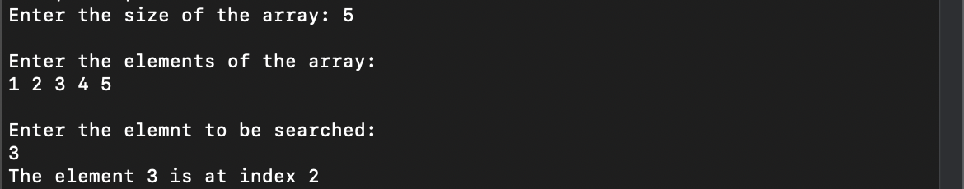

*//C program to print the maximum and minimum element of an array.*

*#include*<stdio.h>

int maxElement(int arr[], int n){

int max = 0;

*for*(int i=1; i<n; i++){

*if*(arr[i]>arr[max])

max = i;

}

*return* arr[max];

}

int minElement(int arr[], int n){

int min = 0;

*for*(int i=1; i<n; i++){

*if*(arr[i]<arr[min])

min = i;

}

*return* arr[min];

}

int main(){

int n;

printf("Enter the size of the array: ");

scanf("%d", &n);

int arr[n];

printf("\nEnter the elements of the array: \n");

*for*(int i=0; i<n; i++){

scanf("%d", &arr[i]);

}

printf("\n");

printf("The elements of the array:\n");

*for*(int i=0; i<n; i++){

printf("%d\t", arr[i]);

}

printf("\n");

printf("The maximum element is: %d", maxElement(arr,n));

printf("\nThe minimum element is: %d", minElement(arr,n));

printf("\n");

*return* 0;

}

**Output:**

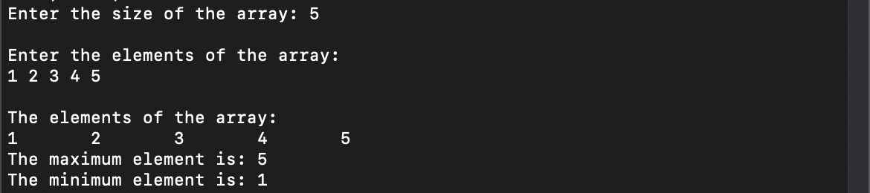

*//C program to reverse an array.*

*#include*<stdio.h>

int main(){

int n;

printf("Enter the size of the array: ");

scanf("%d", &n);

int arr[n];

printf("\nEnter the elements of the array: \n");

*for*(int i=0; i<n; i++){

scanf("%d", &arr[i]);

}

printf("\n");

printf("The elements of the array before reversing:\n");

*for*(int i=0; i<n; i++){

printf(" %d ", arr[i]);

}

printf("\n");

int low = 0, high = n-1;

*while*(low<high){

arr[low]^=arr[high];

arr[high]^=arr[low];

arr[low]^=arr[high];

low++;

high--;

}

printf("The elements of the array after reversing:\n");

*for*(int i=0; i<n; i++){

printf(" %d ", arr[i]);

}

printf("\n");

*return* 0;

}

**Output:**

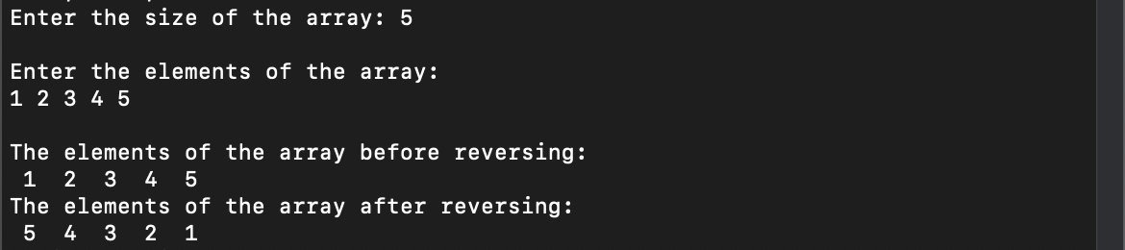

*//C program to sort an array.*

*#include*<stdio.h>

int main(){

int n;

printf("Enter the size of the array: ");

scanf("%d", &n);

int arr[n];

printf("\nEnter the elements of the array: \n");

*for*(int i=0; i<n; i++){

scanf("%d", &arr[i]);

}

printf("\n");

printf("The elements of the array before sorting:\n");

*for*(int i=0; i<n; i++){

printf(" %d ", arr[i]);

}

printf("\n");

*for*(int i=0; i<n; i++ ){

*for*(int j=i+1; j<n; j++){

*if*(arr[j]<arr[i]){

arr[i]^=arr[j];

arr[j]^=arr[i];

arr[i]^=arr[j];

}

}

}

printf("The elements of the array after sorting:\n");

*for*(int i=0; i<n; i++){

printf(" %d ", arr[i]);

}

printf("\n");

*return* 0;

}

**Output:**

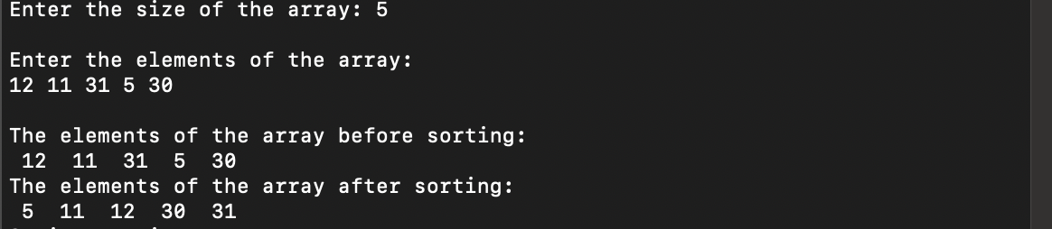

*//C program to print multiplication of 2 matrices and print the transport of the resultant matrix.*

*#include*<stdio.h>

void transpose(int arr[3][3]);

void multMatrix(int a[3][3], int b[3][3]){

int mul[3][3],i,j,k;

*for*(i=0; i<3; i++){

*for*(j=0; j<3; j++){

mul[i][j]=0;

*for*(k=0; k<3; k++){

mul[i][j] += a[i][k]*b[k][j];

}

}

}

printf("The multiplied matrix is: \n");

*for*(i=0; i<3; i++){

*for*(j=0; j<3; j++){

printf("%d\t", mul[i][j]);

}

printf("\n");

}

transpose(mul);

}

void transpose(int arr[3][3]){

int i,j;

printf("The transposed matrix is: \n");

*for*(i=0; i<3; i++){

*for*(j=0; j<3; j++){

printf("%d\t", arr[j][i]);

}

printf("\n");

}

printf("\n");

}

int main(){

int i,j;

int a[3][3], b[3][3];

printf("Enter the values of matrix a: \n");

*for*(i=0; i<3; i++){

*for*(j=0; j<3; j++){

scanf("%d", &a[i][j]);

}

}

printf("\n");

printf("The matrix a is:\n");

*for*(i=0; i<3; i++){

*for*(j=0; j<3; j++){

printf("%d\t", a[i][j]);

}

printf("\n");

}

printf("\n");

printf("Enter the values of matrix b: \n");

*for*(i=0; i<3; i++){

*for*(j=0; j<3; j++){

scanf("%d", &b[i][j]);

}

}

printf("\n");

printf("The matrix b is:\n");

*for*(i=0; i<3; i++){

*for*(j=0; j<3; j++){

printf("%d\t", b[i][j]);

}

printf("\n");

}

printf("\n");

multMatrix(a,b);

*return* 0;

}

**Output:**

